SERMON OUTLINE

DR. FILLMER HEVENER
1-8-10

FROM SCARLET TO SNOW

- WE MUST ALL APPEAR BEFORE THE JUDGMENT THRONE OF GOD. 2 COR. 5:10.
- ALL HAVE SINNED. ROM. 3:23.
- IF WE SIN, WE SHALL DIE. EZE. 18:20.
- WHAT IS THE SOLUTION TO ETERNAL DEATH? IS. 1:18.
- SCARLET, SYMBOL OF SATAN AND SIN (REV. 17),
- HOW IMPORTANT IS HAVING OUR SINS WASHED AWAY BY THE BLOOD OF CHRIST, THE LANB> REV. 17:14.
(NOTE: CHRIST WAS SCOURGED. JOHN 19. ROMAN SCOURGING INVOLVED 39 LASHES BY A 3-TONGUED WHIP, LACED WITH METALS SHAPED LIKE A BAR-BELL. IT IS LIKELY THAT SOME OF THESE HAD CLAW-LIKE PROTRUSIONS. THESE CUT AND PULLED CHRIST’S SKIN AS TWO BURLY ROMAN SOLDIERS ALTERNATELY THRASHED CHRIST’S BACK. JOSEPHUS, THE JEWISH HISTORIAN, WRITES THAT THERE WAS NOT ONE INCH OF JESUS’ BODY THAT WAS NOT CUT, BRUISED, OR BLEEDING.))
- DAVID GLADLY ACCEPTS THE OFFER OF SALVATION. PS. 51: 1-7.
- WILL YOU ACCEPT JESUS’ BLOOD SACRIFICE FOR YOU AND FOLLOW HIM TO ETERNAL LIFE?
- THE UNIVERSAL HUMAN CONDITION IS THAT WE CONSTANTLY SEARCH FOR THE SOLUTION TO THE PROBLEM OF DEATH.
- GOD CASTS OUR SINS TO DEPTH OF SEA. MICAH 7:18-19.
- CHRIST IS FAITHFUL TO FORGIVE US OUR SINS. 1 JOHN 1:9,10.
- FOCUS ON ETERNAL VALUES, NOT MATERIAL VALUES. 1 JOHN 2: 15-17.
- WHO CAN BE SAVED? ANYONE WHO ACCEPTS AND FOLLOWS CHRIST. REV. 7: 9-14.

GUTHRIE MEMORIAL
CHAPEL
2663 CUMBERLAND ROAD (ROUTE 45)
FARMVILLE, VA.
(MAILING ADDRESS: 224 MOHELE ROAD, FARMVILLE, VA. 23901)
(E-MAIL: fhevener@oilart.com)
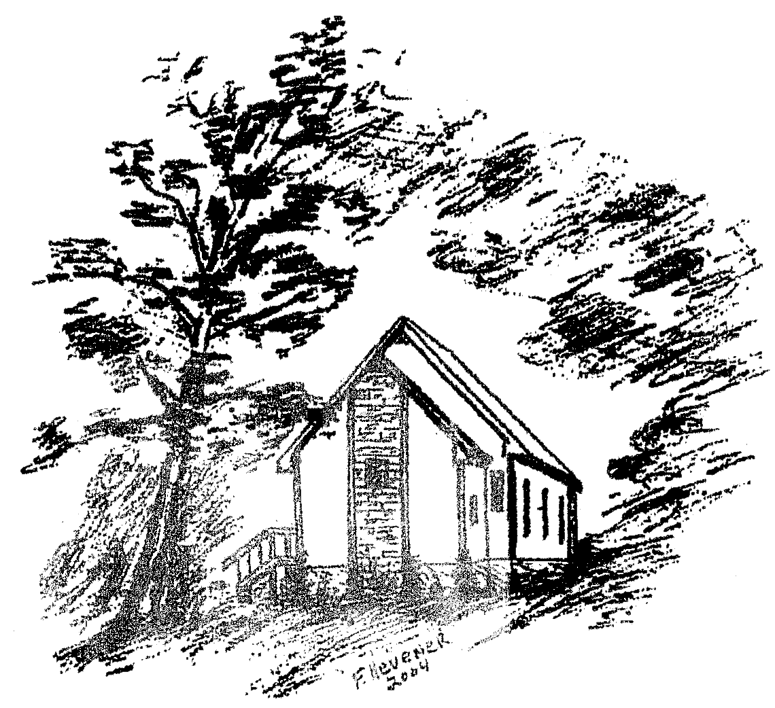
(The Early Chapel, 2004: Ink Drawing by F. Hevener)
(WEB PAGE) www.guthriememorial.org (FOR SPIRITUAL ASSISTANCE, PHONE: (434) 392-6255
DR. FILLMER HEVENER, PASTOR)
1-8-11

